The Company has declared the following Quality Policy statement as a demonstrated commitment towards achieving aims and goals:

The Management and staff of Nigerian Foundries Limited are committed to:

* **Keep the industries of Africa growing by manufacturing tailor-made parts and providing innovative solutions on-time, every time.**
* **Promote the company as a respected provider of quality castings and services to the overall industry of Nigeria, the Gulf of Guinea, and the World over.**
* **Improving our collective productivity and efficiency using new innovations in Information & Communication Technology; to process and provide timely and accurate data at all times, for effective decision making.**
* **Understanding present and future needs of our customers, striving to exceed their requirements and maintaining good relationship with accredited External Providers as they both form an integral part of our success equation.**
* **Maintaining a conducive environment that ensures employees gives their best in order to achieve company’s objectives.**
* **Continually building new activities into the company’s Quality Management System, linking them seamlessly to achieve desired results effectively and cost efficiently.**
* **Setting evaluation standards that are easy to understand, measure and that will show improvement in the overall performance.**
* **Actively minimizing our environmental impact and integrating sustainable practices to address climate change in our operations.**

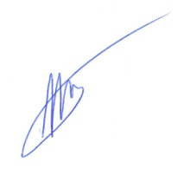

**_______________________**

**Vassily Oye Barberopoulos Date: 30/09/2024**

**Managing Director**